**Name of Senior Center**

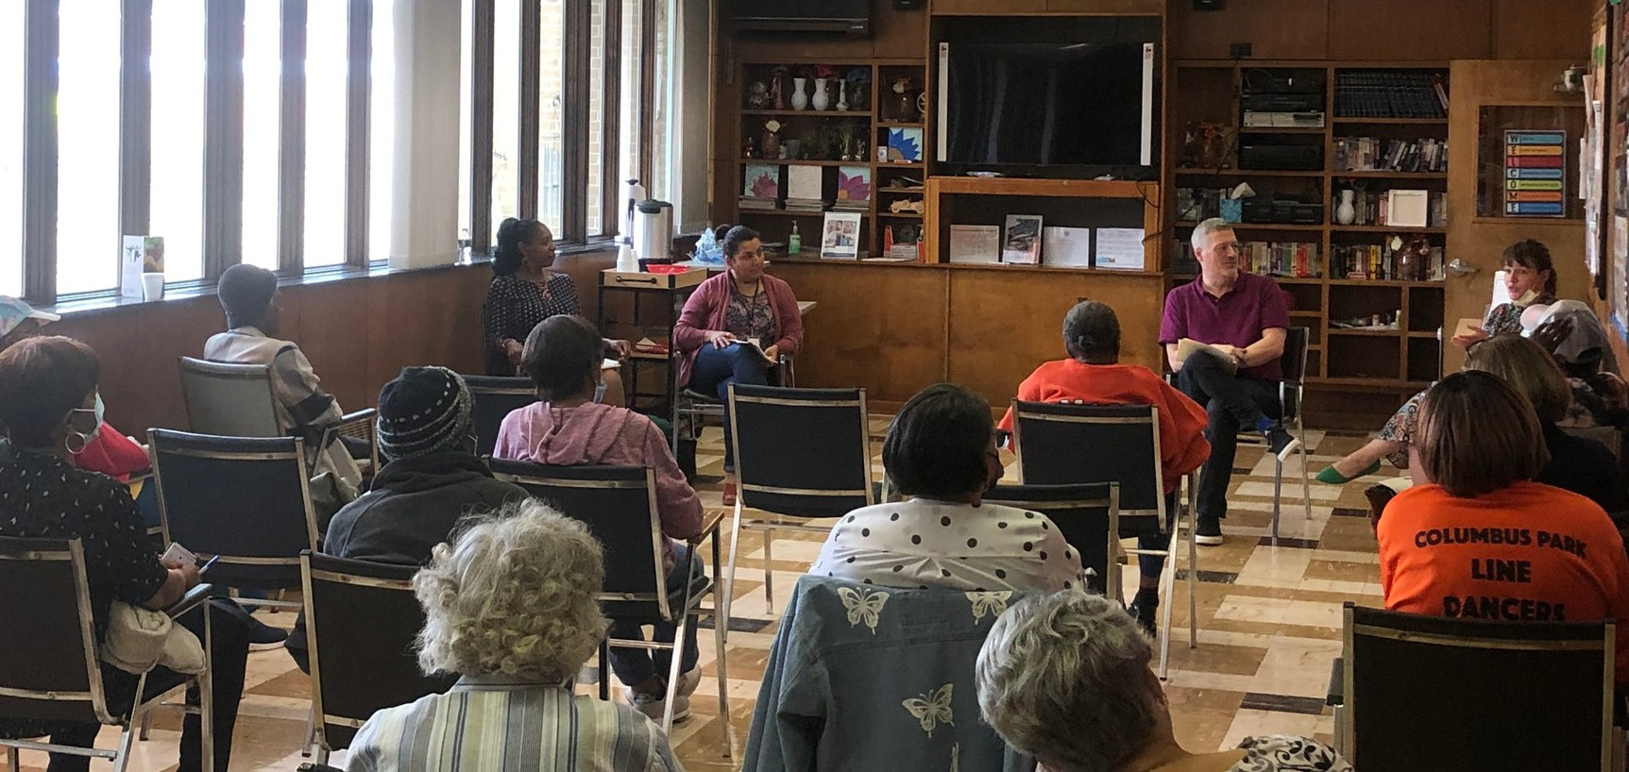

**Aging Well Town Hall**

**WEDNESDAY, MONTH XX, 2023**

Time Location

***Sign up at the front desk***

ADD A DESCRIPTION ABOUT EVENT