Instructions for Accessing Your Virtual Workshop through Zoom

STEP ONE: Receiving an Invitation
First, provide your current email address to the Program Staff, and ensure that you can access that email. The program coordinator will send you an email with a link to access the workshop.
In this email, you will see an important link. Save this email so that you can access this link each week, or write down the URL so you can type it into your browser each week.

STEP TWO: Downloading the Zoom App
You will have to decide if you are going to download Zoom onto your smartphone or tablet, or if you will download Zoom on your laptop or desktop. If you have a smart phone or tablet, we highly recommend you utilize this option.
Option 1: From a tablet or smartphone (simplest and recommended)
- Find and Download the Zoom Application to your phone
  - On Apple products, you will do this from the App Store.
  - On Android or other products, you will download apps from Google Play.
The icon for the app should look like this:

- Confirm the app has downloaded
- If you open the app before the workshop, the app will ask for permission to utilize your microphone and camera. Allow the application access to both.
- Zoom will only access your microphone and camera when you are actively in a Zoom meeting and give it permission to do so.

- You are done! The application has been installed on your device. When it’s time for the workshop, you simply click on the link in your email or type that link into the browser, and the app will launch.
For further instructions, read “Accessing the Workshop”
Option 2: From your laptop or desktop computer
- In your browser, go to https://zoom.us/download
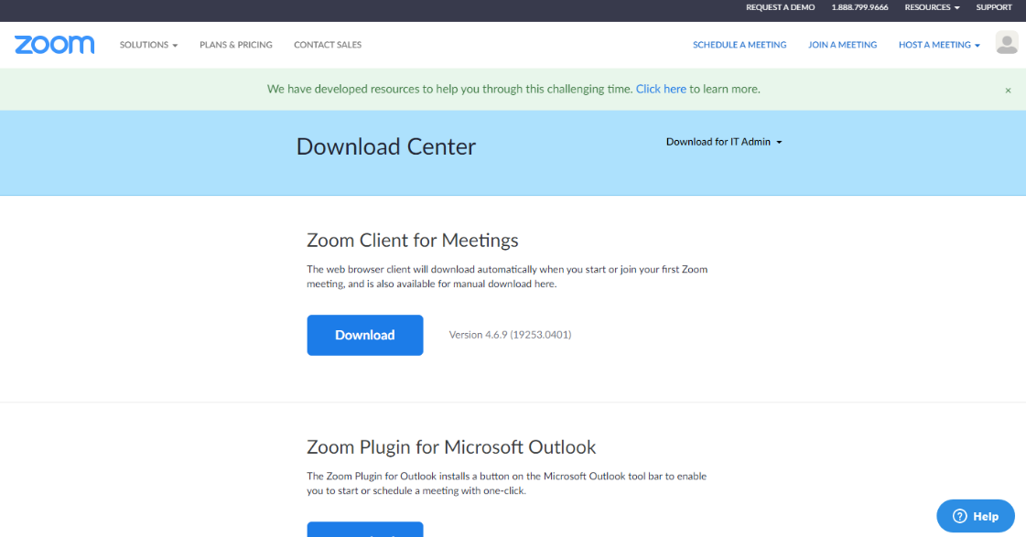
- As seen in the image below, click on “Download” under the option for “Zoom Client for Meetings”
- Clicking this link will prompt your browser to download the software to install the Zoom app onto your computer. This looks different on Mac or PC computers. Follow the prompts and finish installing Zoom onto your desktop.

STEP THREE: Joining the Virtual Workshop
Option 1: From your tablet or smartphone
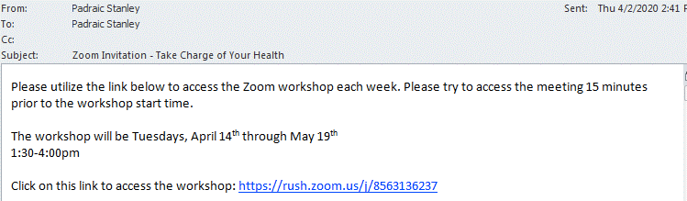
- From your invitation email, tap the link to access the workshop.

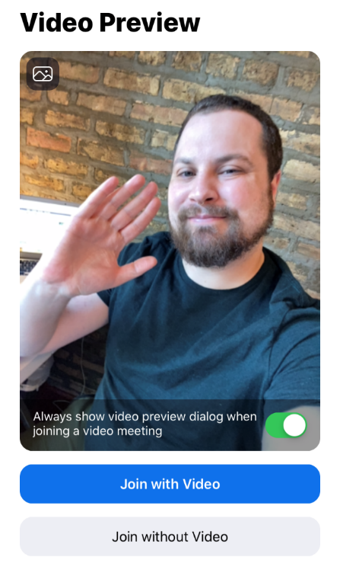
- If you already have the Zoom app installed on your device, the meeting will launch automatically.
- Once the app loads, your camera will turn on and you will see the “Video Preview” (see to left). Don’t worry, at this point no one can see your video, only you! If your video does not show up, it’s because you have not given the Zoom app the permission to use your camera. The app may prompt you to change that. Once your video is showing up on your screen, tap “Join with Video” (see photo).

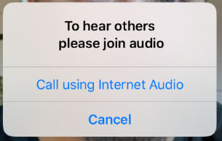
- After you tap “Join with Video,” you will be prompted to turn on your audio with a prompt that says “To hear others, please join audio.”

- On your tablet or mobile device, you will typically only have two options: “Call Using Internet Audio” or “Cancel”—tap “Call Using Internet Audio”. This option will utilize the speaker and microphone on your smartphone or tablet.

- Congratulations! You are in the workshop! You should be able to see and hear other participants, and other participants should hear you. For more information, read “Controls During the Workshop.” The screen should look similar to this photo:
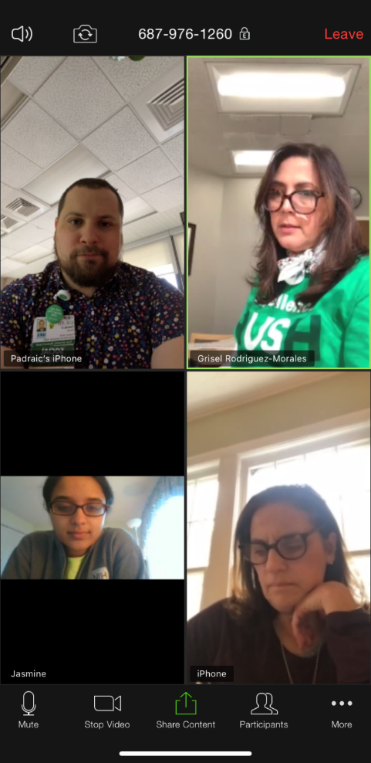
555-555-555

Option 2: From your laptop or desktop computer
- From your invitation email, click the link to access the workshop.

- Clicking this link will open up another screen. On this screen, if you have properly installed the Zoom app to your computer, you will see the following message (see below).

- Click “Open zoom.us”
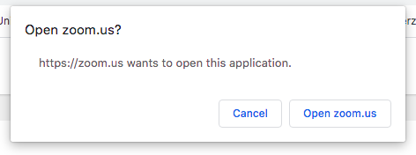
- The Zoom app should launch and you will see the message below asking for your name. Type in your name and click “Join”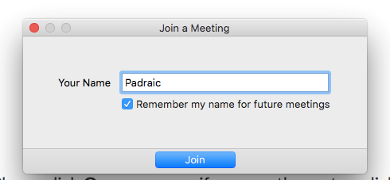

- Once you click join, a screen will pop up titled “Video Preview” and your webcam (if you have one) will turn on. At this point, no one else can see your video, only you! Click “Join with Video.”
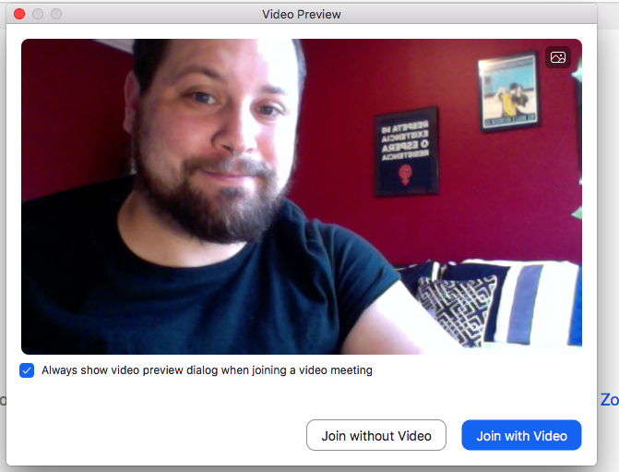

- You will then need to turn on your audio. Most computers will only prompt you to use your computer audio. First, try testing your speaker and microphone by clicking “Test Speaker and Microphone” and follow the prompts.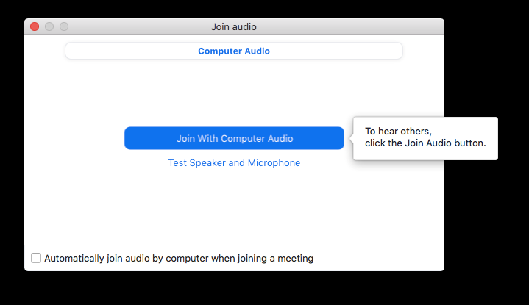

- You should now be able to see and hear all the other participants who have logged on already.

STEP FOUR: Controls During the Workshop
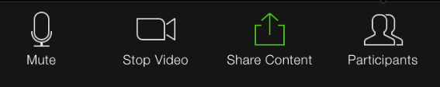
Here are the different controls you should know about to participate in the workshop once you are in:
On Mobile Devices or Tablets

On laptop or desktop

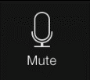
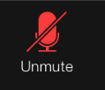
Mute & Unmute: This function is incredibly important. All participants will be muted by the facilitators. However, you can unmute yourself to talk. You can toggle between muting and unmuting by clicking or tapping the mute symbol on the bottom of your screen.
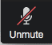
On Tablets or Mobile Devices:
On Laptop/Desktop:

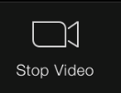
Stop Video: We want to encourage everyone to utilize their video function if at all possible; however, if for some reason you need to turn off your video, you can turn your camera on and off clicking or tapping the camera symbol.
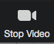
On Tablets or Mobile Devices:
On Laptop/Desktop:

Chat Function: If you have questions that come up when the facilitators have your microphone muted, or if you feel more comfortable typing in your questions or participation, feel free to click/tap on the chat icon. This will open up a chat box, and you can type in your question. You can also click/tap on the chat box to see what other participants are writing. On your mobile device or tablet, you will have to tap “More” and then tap “Chat”
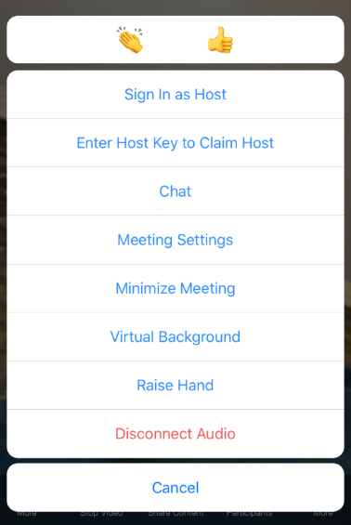
On Laptop/Desktop:

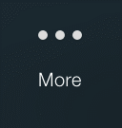
On Tablets or Mobile Devices:

Different Views:
On Your Laptop or Desktop Computer
The Default Setting will always show the video of whoever is speaking. If multiple people are speaking at the same time, the video will show whoever may be speaking louder. If you would like to switch to see everyone’s video, select “Gallery View” in the top right.
On Your Tablet or Mobile Device
You can swipe left and right to change your views. The first window will show the video of whoever is speaking. The second window will show a grid of up to four participants at a time.

