Make a step-by-step plan to improve your health—and your life.  “The class helped me manage my diabetes better, and my A1C is within normal limits now.”  — John in Virginia  “I have learned there are people like me, not living life to the fullest because of a chronic condition, and that we can move forward.”  – Caroline in Washington  “After taking the workshop, I have since lost 25 pounds. I began exercising and eating healthier. After losing the weight along with proper nutrition and exercise, I have been able to get off my blood pressure medicine and my blood pressure now runs about 130/70. I feel great and have a lot more energy.”  —Sam in Virginia | 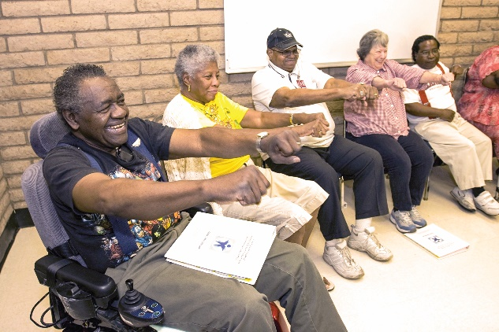  Sign up today—and take charge of your health!  [PROGRAM NAME] is FREE, but spaces  are limited.  Call today: xxx-xxx-xxxx  [ADDRESS]  [WEBSITE] | - “My pain was my boss.  It was telling me what I  could and couldn’t do.  This workshop put ME  back in charge.”  - – Sue from Washington  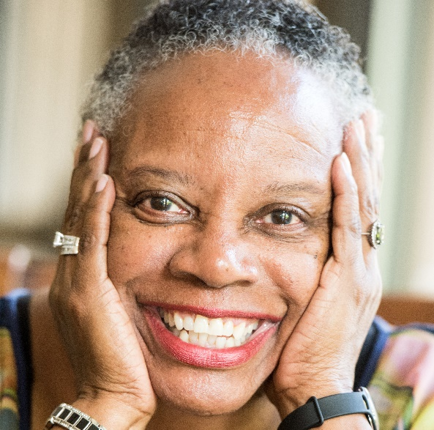  Take charge of your health with  [PROGRAM NAME]
Don’t let an ongoing health condition rule your life.  Living with a chronic condition such as diabetes, arthritis, high blood pressure, heart disease, pain, or anxiety can be a daily challenge. But it doesn’t have to be.  [PROGRAM NAME] offered by [ORGANIZATION NAME] can help you take charge of your health—and feel better. | Get practical tips that you can use right away.  [PROGRAM NAME] is a 6-week workshop that meets for 2.5 hours each week.  - Get support from people like you who are living with ongoing health conditions  - Learn relaxation and other strategies to deal with pain, fatigue, and frustration  - Discover how healthy eating can improve your condition  - Create an exercise program that works for you  - Understand new treatment choices  - Explore how to talk with your doctor and family about your health | [PROGRAM NAME] is FREE and proven to work.  Research has found that people who complete [PROGRAM NAME]:  - Feel healthier and have a better quality of life  - Experience fewer sick days and days in depression  - Are better able to manage symptoms like fatigue, pain, shortness of breath, stress, and sleep problems  - Are more physically active  - Improve communication with their doctors  - Take medications as prescribed  - Feel more confident when completing medical forms

