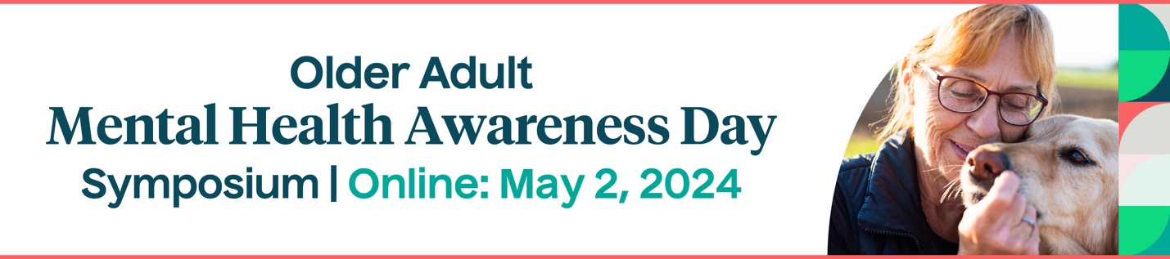

The 7th Annual Older Adult Mental Health Day Symposium
Partner Sharing Toolkit
May 2, 2024

Thank you for helping us spread the word about this year’s 7th annual event on May 2, 2024! Below are suggested social media posts and email text for you to share on your platforms.

FACEBOOK
#MentalHealth is critical to #WellBeing at every age. Attend a free virtual event on May 2, 2024 to get the latest tools to help #OlderAdults in your community.

The 7th Annual Older Adult Mental Health Day Symposium is sponsored @NCOAging, @ACLgov, @HRSAgov, @SAMHSA, and E4Center. #OAMHAD24

Register today to attend! 👇
https://bit.ly/OAMHAD2024

TWITTER
Join @NCOAging, @ACLgov, @HRSAgov, @SAMHSAgov, and E4Center to discover best practices to improve #OlderAdult #MentalHealth.

Register for free today to attend #OAMHAD24 on May 2, 2024 👉 https://bit.ly/OAMHAD2024

LINKEDIN
If you serve older adults, don’t miss the Older Adult Mental Health Day Symposium, a free virtual event with the latest info to improve their #MentalHealth.

This year's 7th annual event is sponsored by @NCOAging, @ACLgov, @HRSAgov, @SAMHSA, and E4Center. #OAMHAD24

Register today to attend on May 2, 2024 👉 https://bit.ly/OAMHAD2024

EMAIL

Subject line: Register for the 7th Annual Older Adult Mental Health Awareness Day Symposium!

Mental health is critical to well-being at every age.

Join a free virtual event on May 2, 2024 that will empower aging services professionals with the latest tools to improve the lives of older adults in their communities.

This all-day symposium is sponsored by the National Council on Aging, the U.S. Administration for Community Living, the Substance Abuse and Mental Health Services Administration, the Health Resources and Services Administration, and the E4 Center of Excellence for Behavioral Health Disparities in Aging.

Register today! https://bit.ly/OAMHAD2024

Once you've registered, share the link to get more people interested and use the hashtag #OAMHAD24. We look forward to seeing you there!

